LED (Light Emitting Diode)

What is an LED made of?
A basic LED is made from a semiconductor material that emits light when electricity passes through it. This process is called electroluminescence. The most commonly used materials are gallium arsenide (GaAs), gallium phosphide (GaP), or a combination of elements like indium, nitrogen, and aluminum, depending on the desired light color.
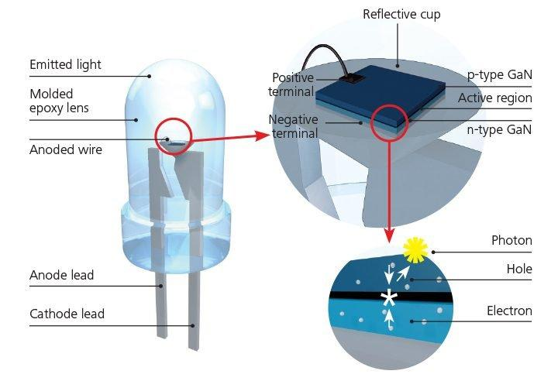

Internal Structure of an LED:
- Semiconductor Chip (Diode Junction)
The core of the LED is a P-N junction, made of:
  - P-type material: has positively charged holes.
  - N-type material: has negatively charged electrons.
When connected to a power supply in the correct direction, electrons move from the N-side and recombine with holes on the P-side. This recombination releases energy in the form of light (photons).
- Reflective Cavity or Cup
The tiny chip is placed inside a reflective bowl or cavity, usually made of silver or aluminum. This reflects the light upward to increase brightness and efficiency.
- Bond Wires
Very thin gold or aluminum wires are used to connect the semiconductor chip to the external legs (leads) of the LED. These wires allow current to reach the chip.
- Lens or Epoxy Dome
The entire structure is encapsulated in a clear or diffused epoxy resin dome. This plastic covering:
  - Protects the internal components from damage
  - Acts as a lens to shape and focus the light
  - Can also be colored to enhance the LED’s color output

How it works:
When you apply voltage in the correct direction (from anode to cathode), current flows through the diode junction. The movement of electrons and holes creates light directly from the semiconductor material. The light color depends on the bandgap of the semiconductor used.
RGB LED Strip (WS2812 or NeoPixel Type)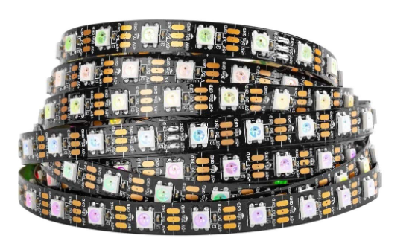

What is an RGB LED Strip made of?
An RGB LED strip consists of a series of individually addressable RGB LEDs, typically based on the WS2812 standard. Each LED on the strip has:
- One red LED chip
- One green LED chip
- One blue LED chip
- An integrated microcontroller or IC
All of these are packaged together into a single small surface-mount component.

Internal Structure of a WS2812 RGB LED:
- Three Separate LED Chips
Each WS2812 unit has three independent LED chips (red, green, blue) that can be combined in various intensities to form any color.
- Control IC (Integrated Circuit)
Every WS2812 LED contains a built-in control circuit. This IC:
  - Receives serial data from the Arduino or controller
  - Decodes the data to decide the brightness of R, G, and B
  - Sends the remaining data to the next LED in the chain
- Signal Input/Output Pins
The LED has data in and data out connections. The controller sends data to the first LED, and each LED passes remaining data to the next one, forming a communication chain.
- Printed Circuit Board (PCB)
The LEDs are mounted on a flexible or rigid PCB strip. This PCB also includes:
  - Copper traces for 5V, GND, and Data line
  - Solder pads for connecting power and microcontroller
  - Sometimes small capacitors or resistors to regulate voltage and signal
- Protective Layer
Most LED strips include a clear silicone or epoxy coating to protect against dust, water, and physical damage.

How it works:
- A digital microcontroller like Arduino sends a serial data stream through the data line.
- Each LED reads the first 24 bits (8 bits per color), sets its brightness, and passes the rest to the next LED.
- The timing of the signal is critical and is handled precisely by the Adafruit NeoPixel library.
- You can program the strip to show all LEDs in one color, cycle through colors, or animate different patterns.

LiquidCrystal I2C Display (16×2) 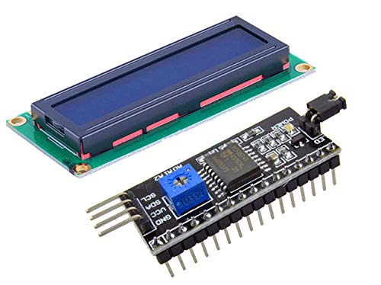

What is it?
The LiquidCrystal I2C display is a 16-character by 2-line LCD screen (16×2) that uses an I2C module attached at the back to reduce the number of wires needed from 16 to just 4 (VCC, GND, SDA, SCL).

Internal Components of LCD I2C:
Part | Description
LCD Panel (HD44780) | This is the main screen that shows characters using liquid crystals arranged in a grid (16 columns × 2 rows).
Liquid Crystals | These materials twist when voltage is applied, blocking or allowing light. This twisting effect forms characters on screen.
LED Backlight | Located behind the screen to illuminate the characters. Controlled via code using .backlight() or .noBacklight().
I2C Backpack (PCF8574 IC) | Converts standard LCD parallel signals into I2C protocol so you only need 2 data pins (SDA, SCL) instead of 6+.
Potentiometer on I2C Module | Tiny knob to adjust screen contrast manually. Turning it changes how visible the letters are.
Registers (Instruction/Data) | The LCD has internal registers for instructions (like clear screen, move cursor) and data (what to print).

How It Works:
- Arduino sends commands over the I2C bus using SDA (Data) and SCL (Clock) lines.
- The I2C module receives these signals and converts them into parallel signals needed by the LCD.
- These signals control which character appears at which position.
- Liquid crystals twist or untwist based on voltage, allowing light to pass or block, forming visible characters.
- The backlight improves visibility of these characters in low light.

Power and Connections:
- VCC → 5V
- GND → Ground
- SDA → A4 (on UNO) / GPIO21 (on ESP32)
- SCL → A5 (on UNO) / GPIO22 (on ESP32)++

BUZZER – Hardware and Working
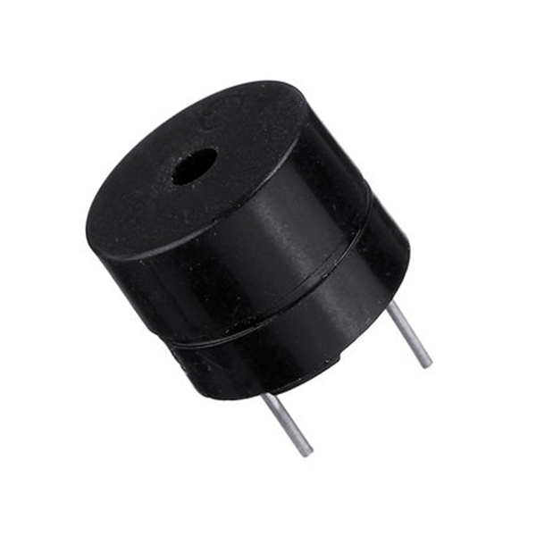

What is a Buzzer?
A buzzer is a simpler output device that creates a fixed or pulsed tone. It’s mainly used for alerts, beeps, and alarms, not full music.

Internal Construction:
There are two types:
- Active Buzzer (most common for Arduino):
  - Has a built-in oscillator circuit.
  - You just give it power and it makes a sound.
- Passive Buzzer:
  - Requires a signal input (like tone from Arduino).
  - Works like a mini speaker without good frequency range.

Inside:
- Piezoelectric disk or coil
- Metal diaphragm on top
- Sometimes an oscillator IC (for active buzzers)

How It Works:
- Piezo Disk Gets Voltage:
  - Applying voltage causes the piezo disk to physically deform (due to piezoelectric effect).
- Disk Vibrates:
  - This vibration is transferred to the diaphragm.
- Sound Output:
  - The diaphragm vibrates air to produce sound (usually high-pitched beep).

Key Points:
- Active Buzzer → plug and play with HIGH/LOW.
- Passive Buzzer → can use tone() for different pitches.
- Usually limited to simple tones or alerts.
- Cheaper, but not suitable for playing music clearly.

Comparison Table: Speaker vs. Buzzer
Feature | Speaker | Buzzer
Output Sound | Music, melodies, voice | Beeps or fixed tones only
Complexity of Sound | High (can play full audio range) | Low (simple alert tones)
Power Requirement | Higher | Lower
Usage | Music projects, robot voice, audio | Alarms, alerts, status beeps
Control Method | PWM or analog signal | HIGH/LOW (Active) or tone() (Passive)
Cost | Slightly higher | Very cheap

Ultrasonic Sensor
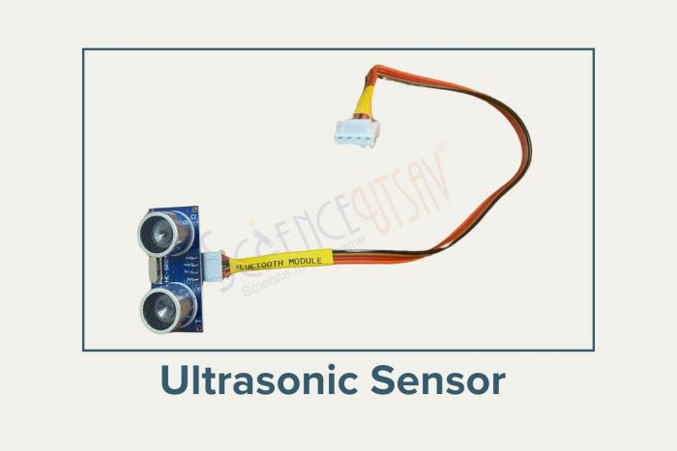
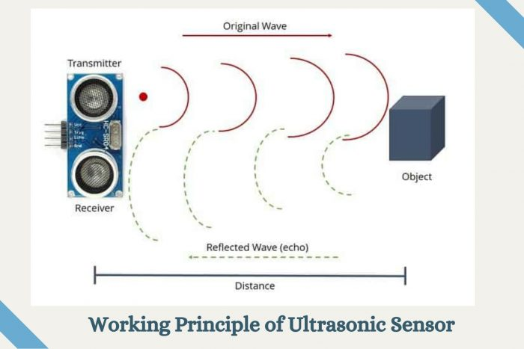
An ultrasonic sensor is a device that emits ultrasonic sound waves and detects their reflection to determine the distance to an object. When integrated into robotics, ultrasonic sensors provide proximity-sensing capabilities.
Types:
Proximity Ultrasonic Sensors: Detect nearby objects within a certain range.
Range Ultrasonic Sensors: Measure the distance to objects within a specified range.
Doppler Ultrasonic Sensors: Detect the movement of objects based on changes in ultrasonic wave frequencies.
Parts of Sensor:
Transmitter: Emits ultrasonic sound waves.
Receiver: Detects reflected sound waves.
Control Circuitry: Processes the received signals and calculates distance.
Housing: Encases the internal components and provides protection.
Working Principle:
Ultrasonic sensors work based on the principle of echolocation. The sensor emits a burst of ultrasonic waves, which travel through the air until they encounter an object. Some of the waves are reflected back to the sensor. By measuring the time it takes for the waves to travel to the object and back, the sensor calculates the distance to the object using the speed of sound in air.
Sensor Pinout:
The pinout of an ultrasonic sensor may vary depending on the manufacturer and model. However, typical pin configurations include:
Vcc (Power Supply)
GND (Ground)
Trigger (Input to trigger the transmission of ultrasonic waves)
Echo (Output to receive the reflected waves)

Safety Measures:
- Avoid dropping the sensor as it is delicate.
- Ensure proper wiring to prevent damage.

Structure:
- Two Eyes: One emits sound waves (transmitter), and the other detects the return wave (receiver).
- Compact Circuit: Combines a transmitter, receiver, and control circuit.

Applications:
- Obstacle Avoidance: Used in robotics to detect obstacles and navigate around them.
- Object Detection: Determines the presence and distance of objects in proximity to the robot.
- Distance Measurement: Measures distances for localization and mapping purposes.
- Parking Assistance: Helps vehicles park by detecting obstacles in the vicinity.
- Level Sensing: Monitors the level of liquids or solids in containers.
- Proximity Sensing: Activates or deactivates devices based on the proximity of objects.
- Security Systems: Detects intruders by sensing their presence in restricted areas.
- Industrial Automation: Controls machinery and equipment based on object proximity.
- Robotics Navigation: Guides robots through environments by detecting obstacles and landmarks.
- Smart Home Applications: Enables smart devices to interact with users and their surroundings based on proximity sensing.

I2C LCD Display
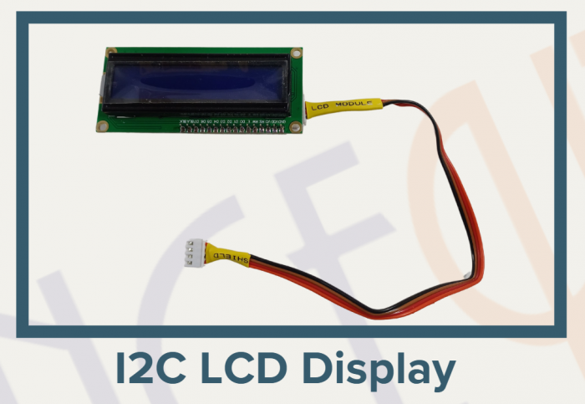
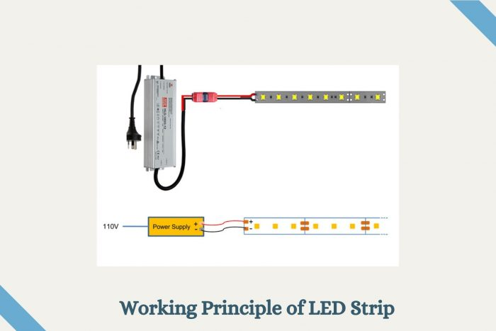
An I2C LCD (Inter-Integrated Circuit Liquid Crystal Display) is a type of display module that uses the I2C communication protocol to interface with microcontrollers and other devices. It offers a convenient way to display information in robotics projects, allowing for easy integration and control.
Types:
- Character LCD Display: Displays alphanumeric characters and symbols.
- Graphic LCD Display: Displays graphical content such as icons, images, and custom patterns.

Parts of Sensor:
- LCD Panel: Displays characters, symbols, or graphics.
- Backlight: Illuminates the display for better visibility.
- I2C Interface: Allows communication with microcontrollers via the I2C protocol.
- Contrast Adjustment: Adjusts the contrast of the displayed content for optimal readability.
- Power Pins: Provides power supply connections.

Working Principle: The I2C LCD display communicates with the microcontroller (e.g., Arduino) using the I2C protocol, which allows multiple devices to communicate with each other using only two wires (SDA and SCL). The microcontroller sends commands and data to the display, instructing it to show specific characters, symbols, or graphics. The display then interprets these commands and updates the screen accordingly.
Sensor Pinout: The pinout of an I2C LCD display typically includes the following pins:
- VCC: Power supply voltage (usually 5V or 3.3V)
- GND: Ground connection
- SDA: Serial Data Line for I2C communication
- SCL: Serial Clock Line for I2C communication
- LED+: Positive terminal of the backlight (if applicable)
- LED-: Negative terminal of the backlight (if applicable)

Applications:
- Robotics Projects: Displays sensor data, system status, and user interface elements in robotics applications.
- Home Automation: Provides visual feedback and control interfaces for smart home systems.
- Weather Stations: Displays weather information such as temperature, humidity, and forecasts.
- Data Loggers: Shows recorded data and logging status in data acquisition systems.
- Industrial Control Systems: Offers user interfaces for monitoring and controlling industrial processes and equipment.
- Educational Projects: Facilitates learning about microcontroller programming and interfacing with displays in educational settings.
- Consumer Electronics: Used in various consumer devices such as digital clocks, timers, and appliances with user interfaces.

How to Use:
- Connect the GND, VCC, SDA, and SCL pins to the Arduino.
- Install the required library (LiquidCrystal_I2C) in the Arduino IDE.
- Write a simple program to display a message.

Safety Measures:
- Handle the screen carefully to avoid scratches.
- Avoid overloading the display with incorrect voltage.

Structure:
- 16×2 Display Grid: Shows 16 characters in each of the 2 rows.
- I2C Module: Makes wiring simpler with fewer connections.
- Blue Backlight: Helps make the text visible in low light.

MQ2 Smoke Sensor
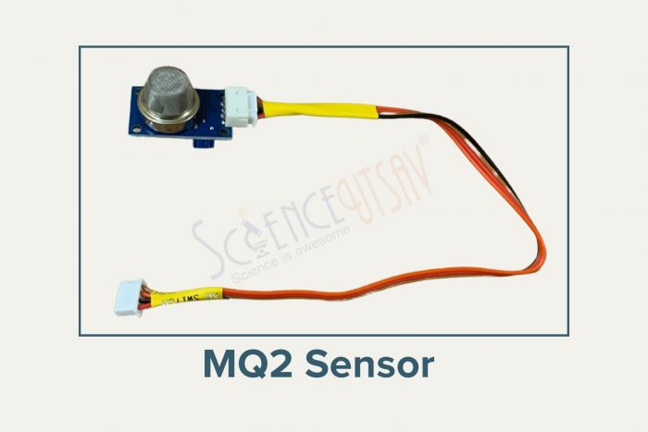
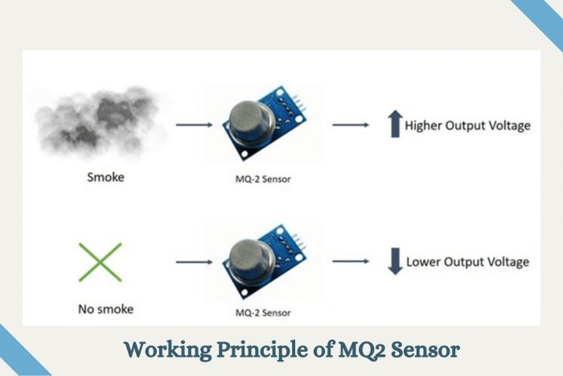
Definition: The MQ2 smoke sensor is a gas sensor module designed to detect various types of gases, including smoke, methane, propane, hydrogen, and alcohol vapor. When integrated into robotics, the MQ2 sensor provides the capability to detect the presence of harmful gases, enabling applications such as fire detection and air quality monitoring.
Types: There are various types of gas sensors available, each designed to detect specific gases. The MQ2 sensor is a multi-gas sensor capable of detecting a wide range of combustible gases and smoke.
Parts of the Sensor:
- Sensing Element: Detects the presence of gases through chemical reactions.
- Heater Coil: Heats the sensing element to facilitate gas detection.
- Electrochemical Sensor: Converts gas concentration into electrical signals.
- Housing: Encloses the internal components and provides protection.
- Pins: Connectors for interfacing with external circuits.

Working Principle: The MQ2 smoke sensor operates based on the principle of gas detection through resistance changes. When the sensor is powered, the heater coil heats the sensing element. When a target gas is present in the environment, it reacts with the sensing element, causing a change in its resistance. This change in resistance is measured and converted into an electrical signal proportional to the gas concentration.
Sensor Pinout: The pinout of an MQ2 smoke sensor typically includes:
- VCC: Positive power supply
- GND: Ground connection
- Analog Output: Voltage output proportional to gas concentration
- Digital Output: Digital signal indicating the presence of gas (optional)

Applications:
- Fire Detection Systems: These are used to detect smoke and initiate alarm systems in case of fire.
- Air Quality Monitoring: Monitors indoor and outdoor air quality by detecting harmful gases.
- Industrial Safety: Ensures safe working environments by detecting gas leaks in industrial settings.
- Environmental Monitoring: Monitors gas emissions in the environment to assess pollution levels.
- Robotics: Integrated into robots for applications such as fire-fighting robots, gas leak detection robots, and air quality monitoring robots.
- Home Automation: Integrated into smart home systems to detect gas leaks and trigger safety mechanisms.
- Automotive Industry: Used in vehicles to detect gas leaks and ensure passenger safety.
- Laboratory Applications: Used in laboratories to detect gas leaks and ensure safety during experiments.
- HVAC Systems: Integrated into heating, ventilation, and air conditioning systems to monitor indoor air quality and detect gas leaks.
- Consumer Electronics: Integrated into wearable devices and gadgets for personal safety and air quality monitoring.

How to Use:
- Connect the VCC, GND, DO, and AO pins to the Arduino.
- Write a program to monitor the gas levels and trigger an alert when smoke or gas is detected.

Safety Measures:
- Avoid exposing the sensor to water or extreme heat.
- Use in a well-ventilated area for accurate results.

Structure:
- Steel Mesh: Protects the internal components.
- Sensing Element: Made of aluminum-oxide ceramic coated with tin dioxide.

Speaker Module

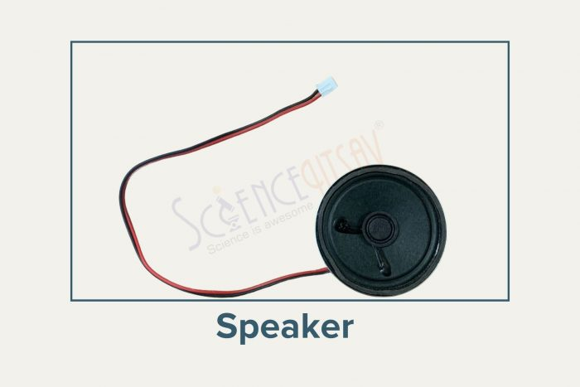
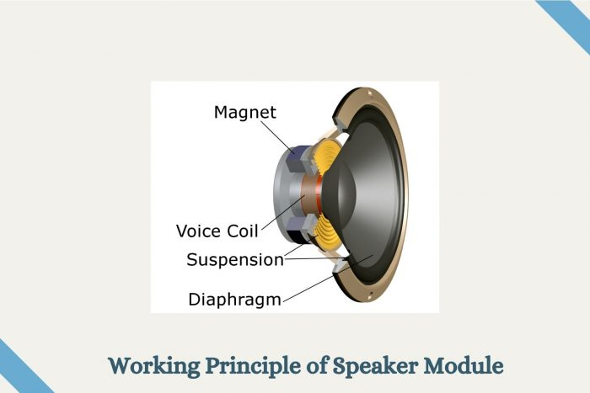
Definition: A speaker module is an electronic device that converts electrical signals into sound waves, producing audible output. In robotics, speaker modules are utilized for audio feedback, communication, and signaling purposes.
Types:
- Electromagnetic Speakers: Commonly used in various applications due to their simplicity and reliability.
- Piezoelectric Speakers: Produce sound by vibrating a piezoelectric crystal and are often used in compact devices.
Parts of the Sensor:
- Diaphragm: A thin membrane that vibrates to produce sound waves.
- Magnet: Generates a magnetic field that interacts with the current flowing through the voice coil.
- Voice Coil: Wire coil attached to the diaphragm that moves within the magnetic field to create sound.
- Enclosure: Provides structural support and helps optimize acoustic performance.

Working Principle: When an electrical signal is applied to the speaker module, it passes through the voice coil, creating a magnetic field. This magnetic field interacts with the magnet, causing the voice coil and diaphragm to move back and forth. As the diaphragm vibrates, it compresses and rarefies the surrounding air, producing sound waves that propagate outward.
Sensor Pinout: The pinout of a speaker module typically includes:
- Positive (+) Terminal
- Negative (-) Terminal

Applications:
- Audio Feedback: Provides audible cues and notifications in robotic systems to indicate status, errors, or completion of tasks.
- Speech Synthesis: Enables robots to communicate with humans by producing spoken words and phrases.
- Alarm Systems: Alerts users of potential hazards or security breaches through audible alarms and sirens.
- Entertainment: Enhances the user experience in robotic toys and entertainment robots by playing music, sound effects, or voice lines.
- Communication: Facilitates two-way communication between robots and users in interactive robotics applications.
- Navigation and Localization: Utilizes sound signals for navigation and localization purposes, especially in robotics for the visually impaired.
- Human-Robot Interaction: Enhances the interaction between humans and robots by conveying emotions, instructions, or responses through sound.

IR Remote

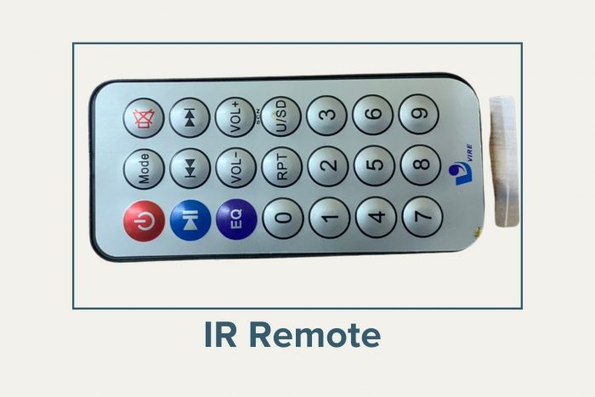
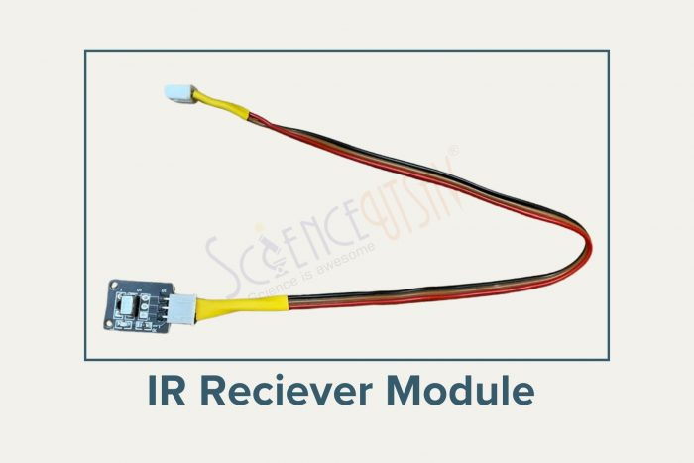

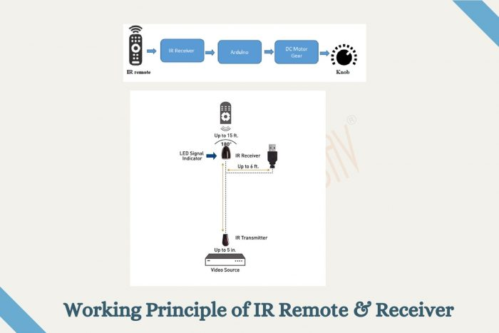
Definition: An Infrared Remote Receiver Module is a small device that can receive signals from an infrared (IR) remote control. It lets you control electronic devices like lights, fans, or robots wirelessly.
Types:
- Standard IR Remote: Typically used for controlling consumer electronics like TVs, DVD players, and audio systems.
- Programmable IR Remote: Offers customizable button configurations for specific applications.
- IR Receiver Modules: Variants designed for receiving and decoding IR signals, available in various sizes and sensitivity levels.
Parts of the Sensor:
- IR LED (Emitter): Emits infrared light signals in a specific frequency range.
- IR Receiver Module: Detects and decodes incoming IR signals.
- Photodiode or Phototransistor: Converts received IR light into electrical signals.
- Signal Processing Circuitry: Processes the received signal to extract data.
- Output Pins: Provide decoded signal output for further processing.
Working Principle: When a button is pressed on the IR remote, the corresponding IR LED emits a modulated infrared signal containing a unique code. The IR receiver module detects this signal, converts it into electrical signals, and demodulates it to extract the transmitted data. The decoded data is then used to trigger specific actions or commands in the robotic system.
Sensor Pinout: The pinout of an IR receiver module typically includes:
- VCC: Power supply input (+)
- GND: Ground connection (-)
- OUT: Outputs the signal received from the remote.

Applications:
- Robot Control: Allows users to wirelessly control robotic systems for movement, functions, or operations.
- Remote Sensing: Enables robots to interact with their environment remotely, such as detecting obstacles or receiving commands.
- Home Automation: Integrates robotic systems with household appliances or devices for remote control and automation.
- Educational Robotics: Facilitates hands-on learning experiences by providing remote control capabilities for educational robot kits.
- Industrial Automation: Incorporates IR remote and receiver systems into manufacturing processes for remote monitoring and control.
- Entertainment: Utilizes IR remotes in robotic systems for entertainment purposes, such as controlling robotic toys or interactive displays.
- Surveillance and Security: Integrates IR remote-controlled robots for surveillance tasks, security monitoring, or remote access control.

Safety Measures:
- Avoid exposing the module to direct sunlight as it may interfere with the signal.
- Handle the module carefully to prevent damage to the pins.

Structure:
- IR Sensor: Detects the infrared signal.
- Circuit Board: Processes the signal and sends it to the microcontroller.

HC-05 Bluetooth Module

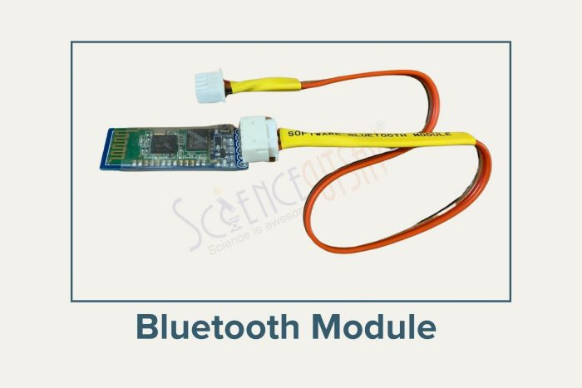
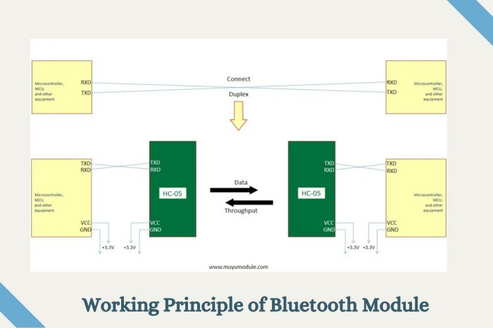
The HC-05 Bluetooth module is a compact electronic device that enables wireless communication between electronic devices over short distances using Bluetooth technology. When integrated into robotics systems, the HC-05 module facilitates wireless control and data transmission between robots and external devices such as smartphones, tablets, or computers.
Types: The HC-05 Bluetooth module is available in various configurations, including:
- HC-05 Master Module: Capable of initiating connections with other Bluetooth devices.
- HC-05 Slave Module: Responds to connection requests from other Bluetooth devices.
- HC-05 Master-Slave Module: Can function as both a master and slave device, enabling versatile communication capabilities.
Parts of the Sensor:
- Bluetooth Chip: Contains the Bluetooth radio transceiver and processing unit.
- Antenna: Facilitates wireless communication by transmitting and receiving radio signals.
- Interface Pins: Connect the module to external devices and provide power and data transmission capabilities.
- LEDs: Indicate the module’s status, such as power and connection status.
Working Principle: The HC-05 Bluetooth module operates by establishing a wireless connection between paired devices using Bluetooth technology. It utilizes radio frequency signals to transmit data packets between the module and connected devices. The module can function as either a master or slave device, depending on its configuration, allowing it to initiate or respond to connection requests.
- The module uses UART (Universal Asynchronous Receiver Transmitter) protocol to send and receive data.
- Data is transmitted wirelessly using Bluetooth technology.
Sensor Pinout: The pinout of the HC-05 Bluetooth module typically includes the following pins:
- VCC: Power supply pin (typically 3.3V or 5V).
- GND: Ground connection.
- TXD: Transmit data pin for serial communication.
- RXD: Receive data pin for serial communication.
- STATE: Status pin indicating the module’s operating mode (e.g., pairing, connected).
- EN: Enable pin for controlling the module’s power state.
- Key: Optional pin for configuring the module’s settings (e.g., baud rate, pairing mode).

Applications:
- Remote Control Systems: Enables wireless control of robotic vehicles, drones, or manipulator arms.
- Sensor Data Transmission: Facilitates wireless transmission of sensor data from robots to external devices for monitoring and analysis.
- Telemetry Systems: Allows real-time monitoring of robot status and performance metrics remotely.
- Human-Machine Interface (HMI): Enables interaction with robotic systems via smartphones, tablets, or computers.
- Multi-Robot Coordination: Facilitates communication between multiple robots for collaborative tasks or swarm robotics applications.
- Automation and Industrial Robotics: Integrates wireless communication capabilities into automated manufacturing processes or industrial robots for remote monitoring and control.
- Education and Research: Provides a platform for learning and experimentation in robotics, allowing students and researchers to develop and test wireless communication protocols and applications.

DC/CD Motor
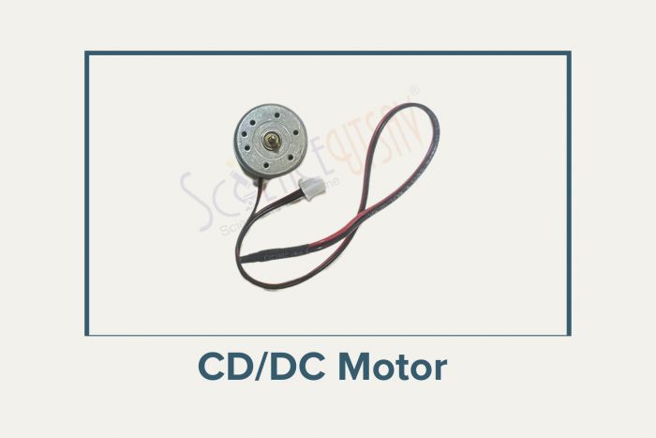
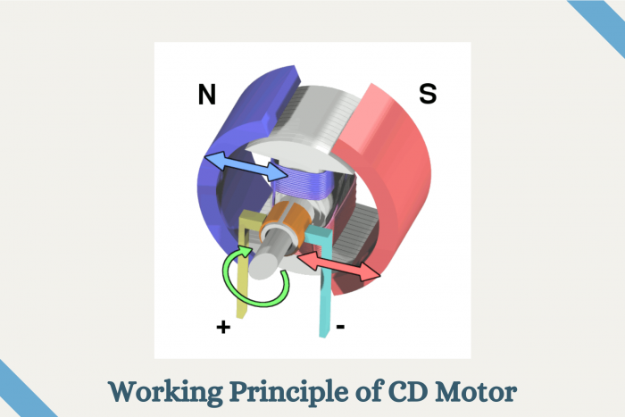
- What is a DC Motor?
  - A motor that uses electricity to spin and make things move.
- How It Works
  - Connect a battery to the motor, and it spins.
  - Switch the wires, and it spins the other way.
- Parts
  - Rotor: The spinning part.
  - Wires: Connect to a battery.
  - Body: Protects the motor.
- Types
  - Simple Motor: Spins one way.
  - Geared Motor: Changes speed.
- Uses
  - Found in cars, fans, and toys.
- Safety
  - Don’t let it get too hot.

Servo motor

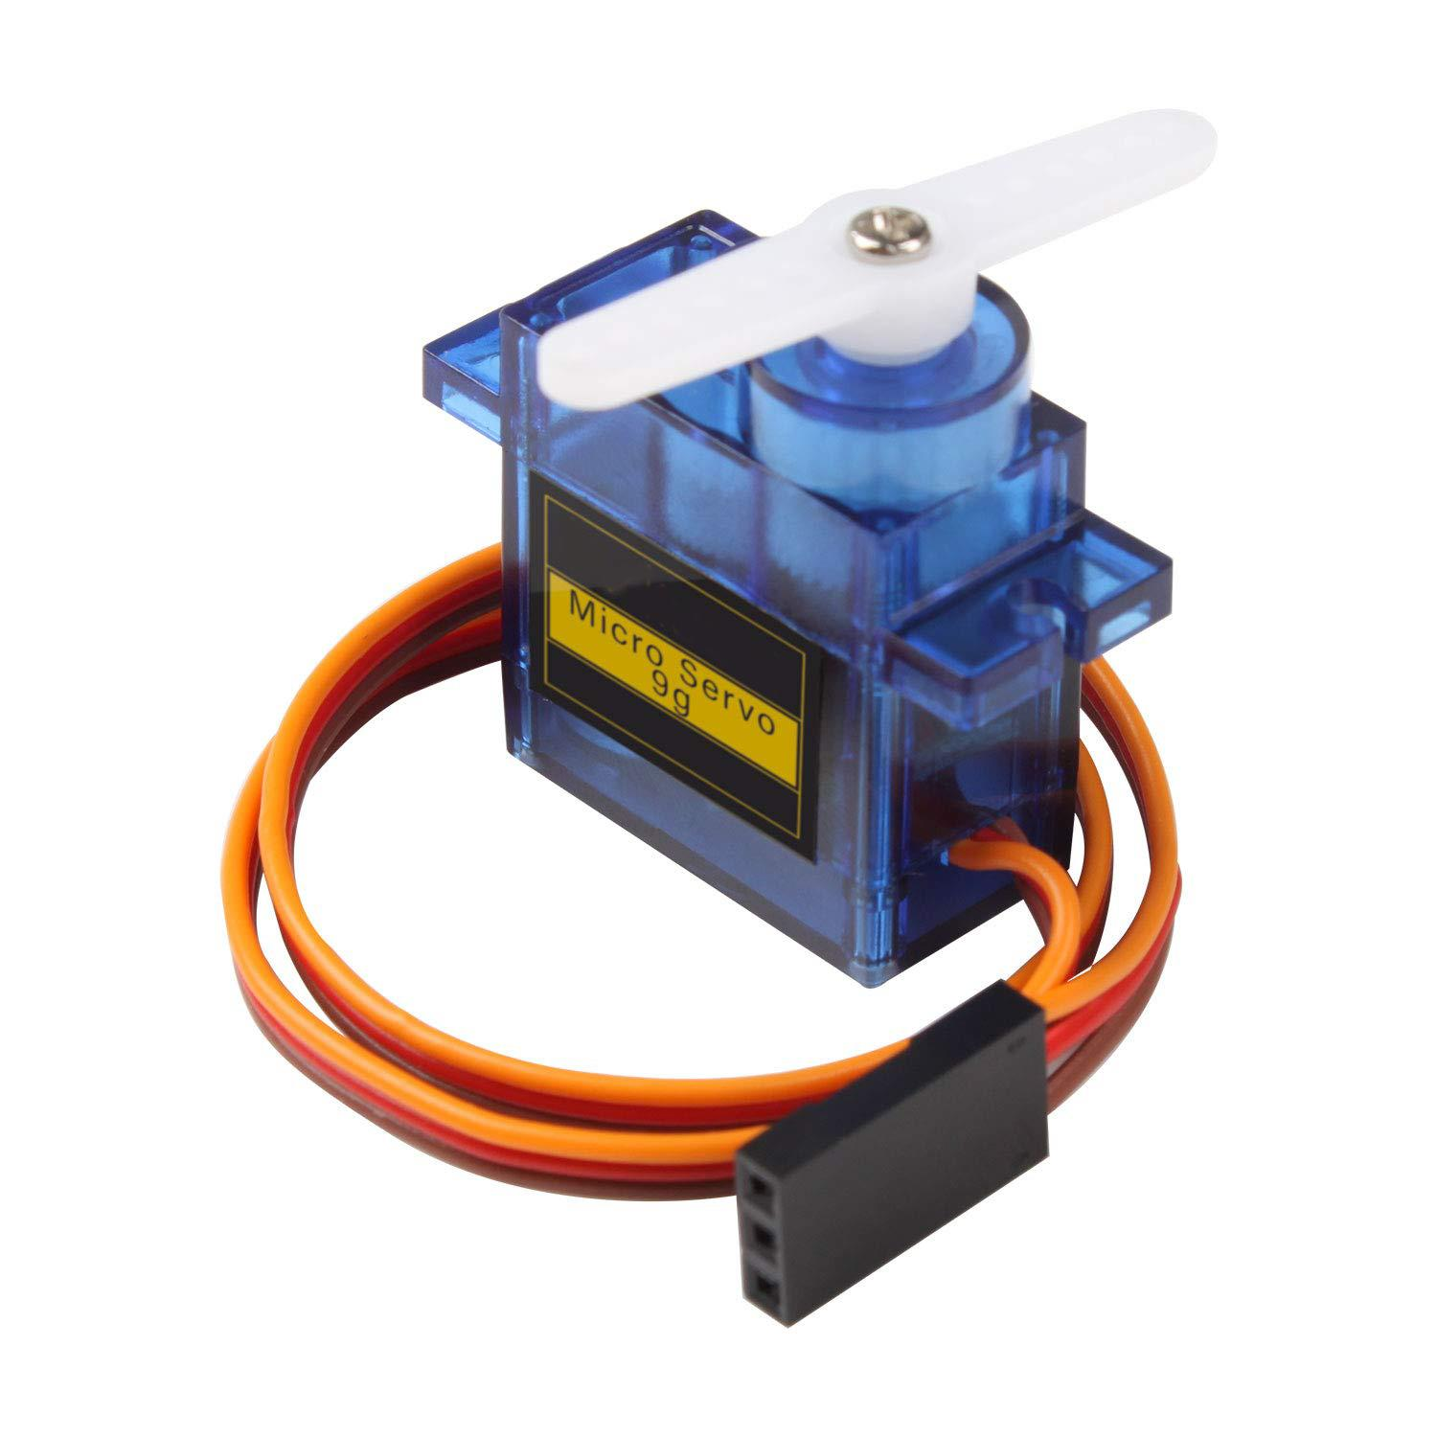

1. What is a Servo Motor?
A servo motor is a type of motor that can rotate to a specific angle or position, unlike normal DC motors that just spin continuously.
- It is commonly used in robotics, RC vehicles, automated doors, and robotic arms.
- It combines a motor, gears, and a control circuit to move to a precise angle.

2. Types of Servo Motors
- Standard Servo Motor
  - Rotates to a specific angle (usually 0° to 180°).
  - Often used in small robotic projects (like SG90).
- Continuous Rotation Servo
  - Rotates continuously like a DC motor, but speed and direction are controlled.
  - Used for wheels of robots.

3. Hardware of a Standard Servo Motor (e.g., SG90)
A typical small servo motor has 3 wires:
Wire Color | Pin Name | Function
Brown / Black | GND | Connect to ground
Red | VCC | Connect to power (+5V)
Orange / Yellow | Signal | Receives control signal (PWM)
- The motor inside is connected to gears, which increase torque and control position.
- The control circuit receives a PWM signal to move the motor to the desired angle.

4. How a Servo Motor Works
- The microcontroller sends a PWM signal to the servo’s control pin.
- The pulse width determines the angle of rotation:
  - ~1ms pulse → 0°
  - ~1.5ms pulse → 90° (middle)
  - ~2ms pulse → 180°
- The servo’s internal gears and control circuit rotate the motor shaft to the required position.
- The servo can hold that position even under load.
Unlike DC motors, the servo doesn’t just spin; it moves precisely to a desired angle.

5. Applications of Servo Motors
- Robotic arms for precise movement
- RC cars, planes, and boats for steering
- Automated door locks and valves
- Camera pan/tilt mechanisms
- STEM and robotics projects in schools

6. Key Points to Remember
- Servo motors are position-controlled motors.
- Use a PWM signal to control the angle.
- Can rotate 0°–180° (standard servo) or continuously (continuous rotation).
- Require power (5V), ground, and signal to work.
- Very useful for projects requiring precise movement.

Push button
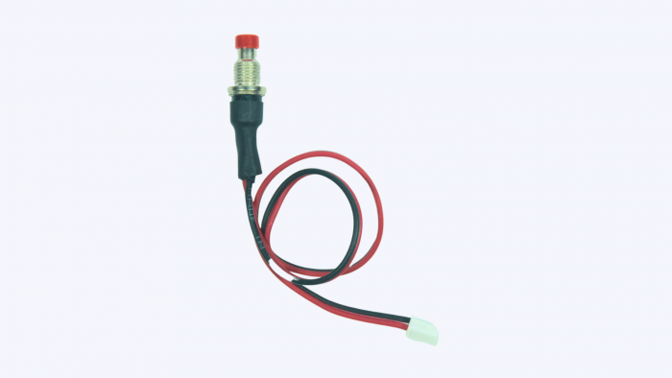

Working Explanation:
A 2-pin push switch is a momentary switch — it only connects the circuit while being pressed.
Once you release it, the connection breaks automatically.

How it Works:
- Press the switch: Circuit is completed → Device turns ON
- Release the switch: Circuit breaks → Device turns OFF

Pinout (2-pin):
- Pin 1: Connect to input side
- Pin 2: Connect to output side
Polarity doesn’t matter — simple open/close contact.

Uses:
- To send temporary input to microcontrollers
- Reset or trigger actions
- Momentary control applications

Real-Life Examples:
- Doorbell buttons
- Toy buttons
- Elevator button (older type)

Flame sensor
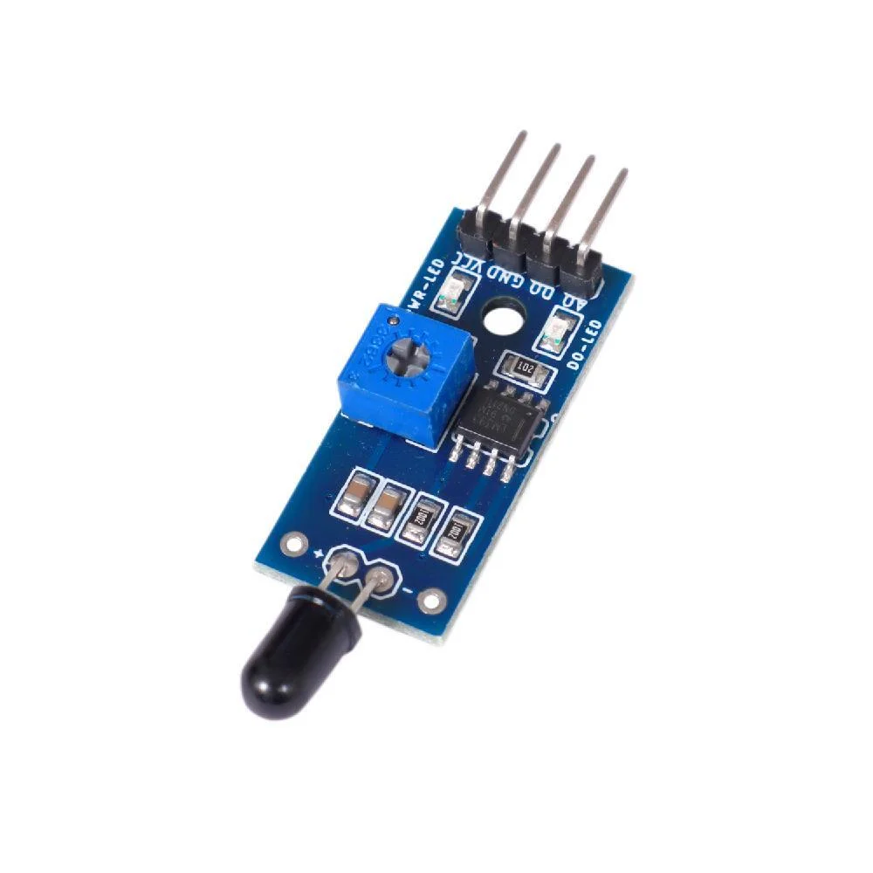
Description: A flame sensor definition is a type of detector that is used to detect as well as react to the occurrence of a fire or flame. A flame sensor frequently responds faster & more precisely as compared to a heat or smoke sensor because of the mechanisms it utilizes to notice the flame. These sensors are also used in an ignition system to get precise actions otherwise to inform the operator. In safety equipment, flame sensors, fire alarms, and smoke sensors play a major role because these sensors assist us in maintaining our offices, homes, or stores very safe from fire accidents. Generally, safety equipment is used in almost all apartments, modern homes, cinema halls, offices, and shopping malls, and in some regions, it is compulsory to fire security devices. To overcome this problem, a flame sensor is used to protect all these from fires or flames.

Features:
- 1. Indicator light: a green one for the switch, a red one for power.
- 2. Built in a potentiometer for sensitivity control.
- 3. On-board signal output indication, output effective signal is high, at the same time the indicator light up, the output signal can directly connect to microcontroller IO.
- Can detect fire or wavelength in 760 ~ 1100 nm nano within the scope of the light source.
- Detection angle about 60 degrees, the flame spectrum especially sensitive.
- The flame of the most sensitive sensors flame, the regular light is also a response, generally used for fire alarm purposes.

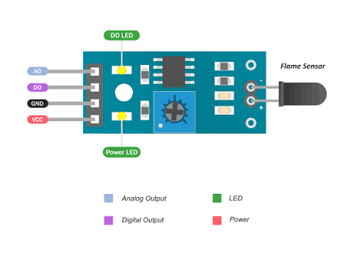

Pin Configuration & Indicators
- VCC: Power input (3.3V to 5V)
- GND: Ground
- DO (Digital Out): Binary switch output (Low on flame detection, High otherwise)
- AO (Analog Out): Real-time voltage output relative to infrared light intensity
- LED Indicators: Red LED for power status; Green LED for digital switch trigger
- Adjustment: Onboard potentiometer (10k trimmer) to calibrate detection sensitivity threshold
Applications:
- A flame-sensor is mainly used to detect & react to the occurrence of a flame/fire.
- Flame sensors are used in fire alarms, fire detection, drying systems, firefighting robot, industrial heating, hydrogen stations, domestic heating systems, industrial gas turbines, gaspowered cooking devices, etc.
- These are used in MDF factories, pharmaceuticals, fume cupboards, coal handling, spray booths, nuclear industry, fabrication of metal, clothing dryers, aircraft hangars, gas fuelled cookers, domestic heating systems, heating & drying systems in industries, generators & storage tanks.
Vibration sensor
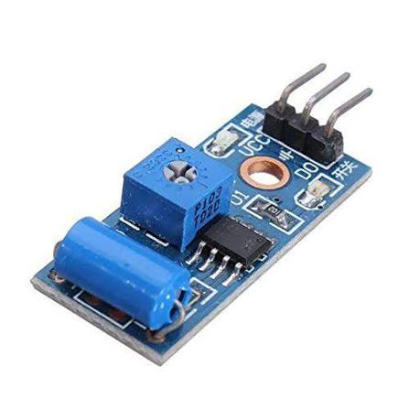

1. Small Description & Type
- Description: A device that detects mechanical vibrations, shocks, or tilts.
- Common Type: SW-420 (Rolling ball / Spring-based non-directional vibration switch).

2. How it Works
- Mechanism: An internal flexible spring wraps around a central metal post.
- Trigger: Movement or vibration causes the spring to shake and touch the post.
- Circuit: This touch closes the circuit momentarily, changing the output state.
- Processing: An onboard LM393 comparator digitizes this signal into a clean HIGH/LOW output.
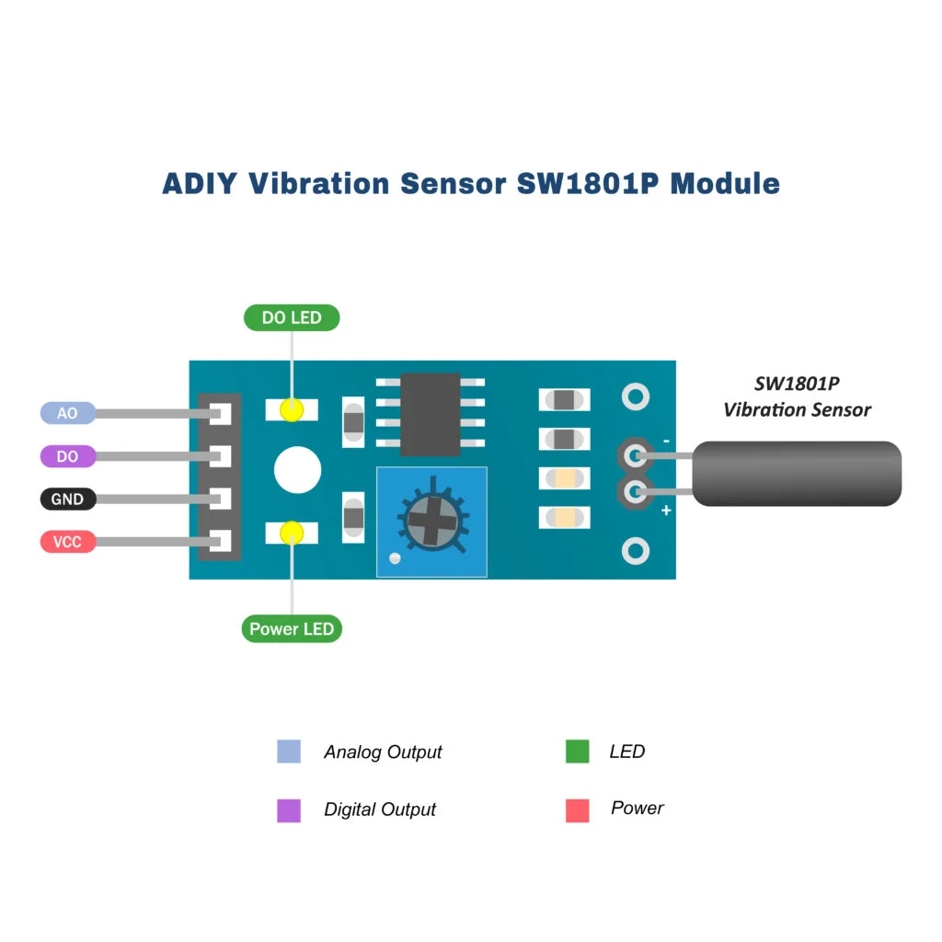

3. Pin Configuration (Standard 3-Pin Module)
- VCC: Power supply input (typically 3.3V to 5V DC).
- GND: Ground connection (0V).
- DO (Digital Output): Outputs LOW when vibration is detected; outputs HIGH when stable.

4. Technical Specifications
- Operating Voltage: 3.3V to 5V DC
- Operating Current: ~15 mA
- Output Format: Digital switching outputs (0 and 1)
- Dimensions: ~32mm x 14mm

5. Applications & Uses
- Security Systems: Anti-theft alarms for vehicles and building windows.
- Smart Devices: Wake-on-shake features for remote controls or wearables.
- Industrial: Machinery health monitoring and impact detection.
- Earthquake Alarms: Early warning tremor detection systems.

6. Safety Measures
- Current Limits: Avoid drawing power directly from the DO pin; use a microcontroller or transistor.
- Waterproofing: The standard SW-420 module is not waterproof; protect it from moisture to prevent short circuits.
- Mechanical Stress: Do not subject the sensor to forces beyond its rated shock limit to avoid permanent spring deformation.

BO motor
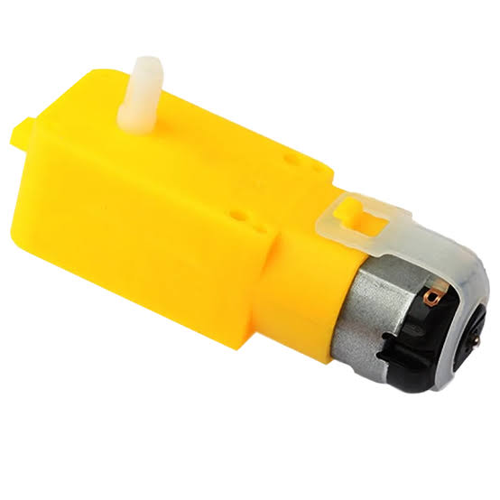
1. Small Description & Type
- Description: A lightweight, low-cost DC motor paired with an internal plastic gearbox to trade speed for high twisting power (torque).
- Common Type: BO (Battery Operated) Dual-Shaft or Single-Shaft Yellow Gear Motor.
2. How it Works
- Mechanism: Direct current (DC) powers an internal miniature brushed motor, causing it to spin at a very high speed.
- Gearbox: A series of plastic spur gears reduces this high RPM down to a manageable, useful speed.
- Output: The gear reduction drastically multiplies the rotational force (torque) delivered to the output shaft to turn wheels.
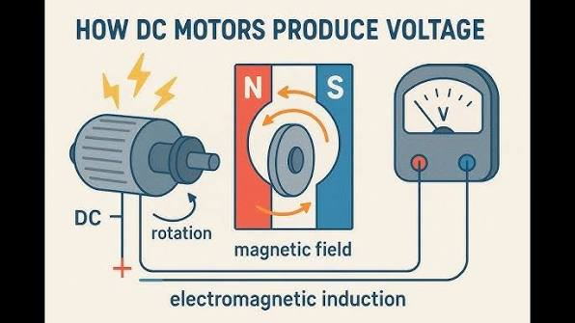
3. Pin Configuration
- Terminal 1 (Positive/Negative): Connects to the motor driver output to control rotation direction.
- Terminal 2 (Negative/Positive): Reversing the polarity between Terminal 1 and 2 reverses the spinning direction.
4. Technical Specifications
- Operating Voltage: 3V to 6V DC (Standard operating sweet spot is 5V-6V).
- No-Load Current: ~150 mA to 200 mA.
- Load Current: ~600 mA to 800 mA (Stall current can exceed 1A).
- Speed (No Load): ~125 RPM to 200 RPM (Depending on voltage).
- Gear Ratio: Commonly 1:48 or 1:120.
5. Applications & Uses
- Robotics: Driving wheels for 2WD/4WD DIY smart robot cars and line-following robots.
- Automation: Powering simple conveyor belts and mechanical toy linkages.
- Education: STEM school projects to demonstrate basic gear mechanics and electronics.
6. Safety Measures
- Motor Driver Required: Never connect a BO motor directly to microcontroller pins (like Arduino); it draws too much current and will fry the board. Use an L298N or L293D driver.
- Mechanical Load: Do not block or stall the wheels while power is applied; holding the motor completely still can melt the internal plastic gears or burn out the coils.
- Voltage Limit: Avoid exceeding 9V DC to prevent damaging the delicate internal brushes.
Motor driver
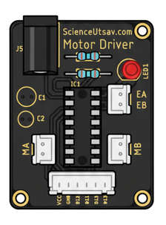
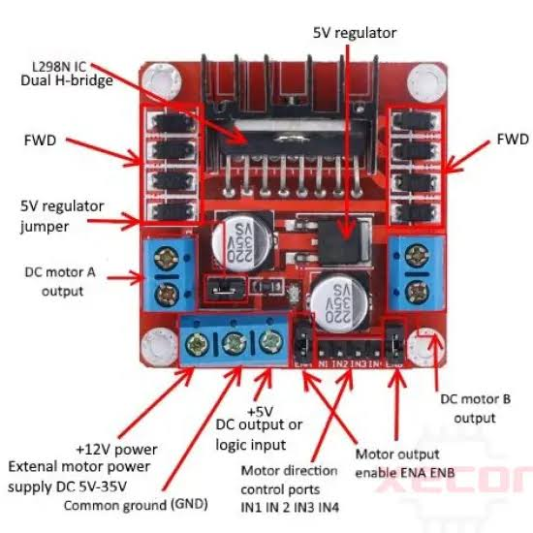
1. Small Description & Type
- Description: An electronic circuit board that acts as an intermediate power amplifier between a low-current microcontroller and high-current motors.
- Common Type: L298N Dual H-Bridge Motor Driver Module (or the smaller L293D / TB6612FNG modules).
2. How it Works
- Logic Isolation: Microcontrollers cannot safely output enough current to drive motors directly without frying their circuitry.
- H-Bridge Mechanism: The driver utilizes internal electronic switches (transistors or MOSFETs) arranged in an "H" shape structure.
- Direction Control: Closing opposing switches changes the polarity of the current flowing through the motor, reversing its spin.
- Speed Control: It accepts high-speed Pulse Width Modulation (PWM) signals from a controller to turn the motor power on and off rapidly, modifying the average speed.
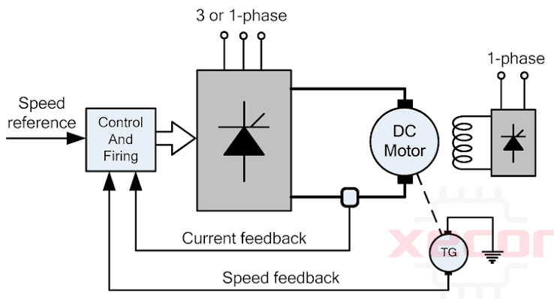
3. Pin Configuration (Standard L298N Module)
- Power Terminals:
  - VCC: Main external power input for the motors (typically 5V to 35V DC).
  - GND: Common ground reference (must connect to both battery and microcontroller grounds).
  - 5V: An onboard regulated 5V output to power the microcontroller (if the 5V jumper is kept active).
- Motor Outputs:
  - OUT1 & OUT2: Connected directly to Motor A terminals.
  - OUT3 & OUT4: Connected directly to Motor B terminals.
- Logic Inputs:
  - IN1 & IN2: Digital inputs to control the spinning direction of Motor A.
  - IN3 & IN4: Digital inputs to control the spinning direction of Motor B.
  - ENA & ENB: Enable pins used for PWM speed control (remove jumpers to attach PWM pins).
4. Technical Specifications
- Motor Supply Voltage: 5V to 35V DC
- Logic Voltage: 5V DC
- Peak Output Current: Up to 2A per motor channel (continuous limits are generally lower around 1A to 1.2A).
- Max Power Dissipation: 25W (requires the built-in aluminum heatsink at higher currents).
5. Applications & Uses
- Mobile Robots: Powering wheels on autonomous mobile robots (AMRs), RC cars, and line-following robots.
- Precision Actuators: Driving bipolar or unipolar stepper motors for basic linear rails.
- Automation: Controlling miniature DC pumps, heavy-duty relays, and high-current LED strips.
6. Safety Measures
- Common Ground: Always connect the motor driver’s GND pin to your microcontroller's GND pin to prevent unpredictable control signals or erratic motor behavior.
- Flyback Protection: Ensure the PCB features protective flyback diodes (integrated inside the L298N) to catch high-voltage spikes generated when a motor stops spinning.
- Overheating: Keep the aluminum heatsink clear of wires and obstruction; do not operate near peak current limits (2A) continuously without active cooling.
- Voltage Drops: Account for an inherent internal voltage drop of roughly 1.5V to 2V across the older L298N chip when calculating your required battery supply.
Submersible pump
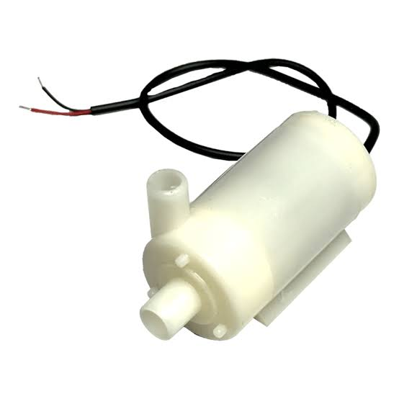
Small Description & Type
- Description: A hermetically sealed water pump designed to be fully submerged directly inside the liquid it is pumping.
- Common Type: Mini 3V-6V DC Micro Submersible Water Pump (frequently used in DIY projects).
2. How it Works
- Mechanism: The DC motor is encased inside a waterproof housing to isolate it from the liquid.
- Centrifugal Force: The motor spins an internal impellor wheel at high speed.
- Displacement: This spinning action creates a vacuum, drawing water into the inlet and forcing it out through the discharge nozzle.
3. Pin Configuration
- Positive Lead (Red Wire): Connects to the positive power supply or motor driver output.
- Negative Lead (Black Wire): Connects to the ground (GND) or motor driver output.
- Directional Note: Reversing these wires will cause the impeller to spin backward, which significantly reduces or stops water flow without harming the motor immediately.
4. Technical Specifications
- Operating Voltage: 3V to 6V DC
- Operating Current: ~100 mA to 200 mA
- Flow Rate: Approximately 80 to 120 Litres per hour (L/H)
- Max Lift (Head): ~0.4 to 1.1 metres
- Material: Engineering-grade ABS plastic
5. Applications & Uses
- Smart Agriculture: Automated plant watering and soil moisture management setups.
- Home Decor: Powering desktop water fountains and small decorative waterfalls.
- Aquariums: Miniature fish tank water circulation and filtration systems.
6. Safety Measures
- No Dry Running: Never run the pump without water; operating it completely dry will rapidly overheat and destroy the internal seals and impeller.
- Water Level: Ensure the fluid level always stays fully above the intake nozzle to prevent airlocking or motor damage.
Rain sensor
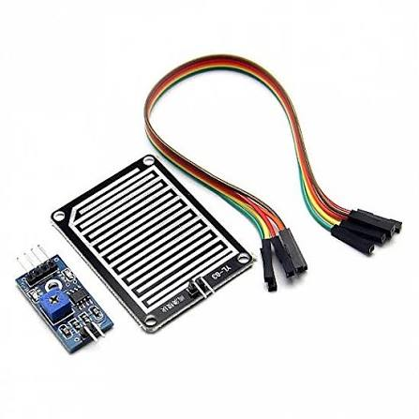
1. Small Description & Type
- Description: A device that detects moisture levels on its surface, indicating rain intensity.
- Common Type: FC-37 / YL-83 Resistive Rain Sensor Module.
2. How it Works
- Mechanism: The sensor pad features conductive nickel tracks laid out in an interleaved pattern.
- Resistance Change: Dry weather keeps track resistance high; falling water drops bridge the tracks, drastically dropping the resistance.
- Processing: An onboard LM393 comparator reads this change, outputting an analog voltage or a digital trigger signal.
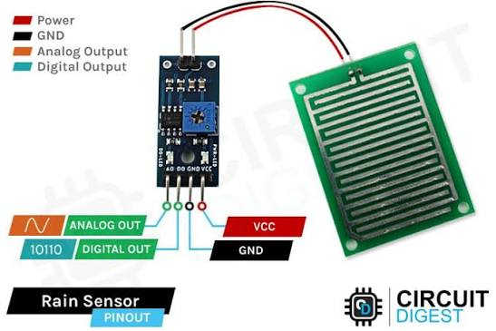
3. Pin Configuration (Standard 4-Pin Module)
- VCC: Power supply input (3.3V to 5V DC).
- GND: Ground connection (0V).
- DO (Digital Output): High/Low switching output based on a preset moisture threshold.
- AO (Analog Output): Real-time voltage output (0V to 5V) that decreases as rain gets heavier.
4. Technical Specifications
- Operating Voltage: 3.3V to 5V DC
- Operating Current: ~15 mA
- Output Format: Dual outputs (Analog voltage and Digital high/low)
- Sensing Pad Size: ~50mm x 40mm
5. Applications & Uses
- Smart Home: Automated window-closing systems and motorized awning retractors.
- Automotive: Triggering automatic windshield wipers on vehicles.
- Weather Stations: Low-cost environmental monitoring and weather logging setups.
- Agriculture: Halting automated irrigation controllers when real rain is detected.
6. Safety Measures
- Corrosion Mitigation: Avoid powering the sensing pad continuously; keep its VCC pin linked to a digital output pin on your controller, turning it on only during readings to prevent rapid electrolysis.
- Electronics Isolation: Only the flat sensing pad should face the elements; the separate LM393 amplifier board must remain completely dry inside a waterproof enclosure.
- Debris Build-up: Regularly clean dust or mineral scaling off the sensing pad tracks to prevent false or sticky moisture readings.
Moisture sensor
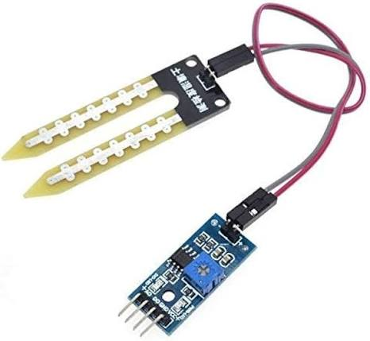

1. Small Description & Type
- Description: A sensor that measures the volumetric water content or moisture levels inside soil.
- Common Type: YL-69 / HL-69 Resistive Soil Moisture Sensor (with an LM393 comparator board).

2. How it Works
- Mechanism: Two exposed metal probes are inserted directly into the soil.
- Resistance Change: Dry soil conducts poorly (high resistance); wet soil conducts easily due to water and ions (low resistance).
- Processing: Current passes between the probes, and the amplifier module converts this resistance into a readable voltage signal.
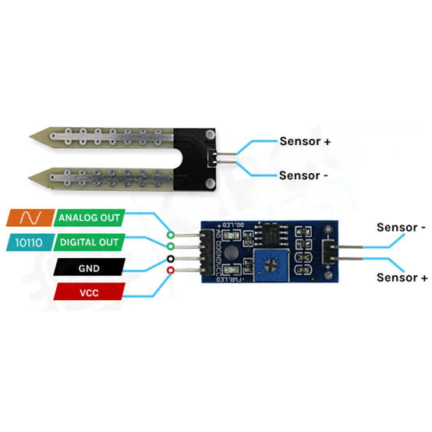

3. Pin Configuration (Standard 4-Pin Module)
- VCC: Power supply input (3.3V to 5V DC).
- GND: Ground connection (0V).
- DO (Digital Output): High/Low signal triggered when soil dryness passes a manual threshold.
- AO (Analog Output): Variable voltage (0V to 5V); drops closer to 0V as the soil gets wetter.

4. Technical Specifications
- Operating Voltage: 3.3V to 5V DC
- Operating Current: ~35 mA
- Probe Dimensions: ~60mm x 20mm
- Output Signal: Analog value and Digital switching threshold

5. Applications & Uses
- Smart Agriculture: Automated drip irrigation networks and greenhouse monitoring.
- Home Gardening: Automated plant pot watering systems and soil health kits.
- Environmental Research: Logging long-term forest soil moisture and land erosion tracking.

6. Safety Measures
- Probe Corrosion: Resistive probes corrode quickly due to electrolysis; power the sensor via a microcontroller digital pin only during the seconds you take a reading.
- Module Protection: Keep the small LM393 amplifier board completely dry; only the lower metal fork should be pushed into wet soil.
- Calibration Drift: Soil minerals build up on the metal tracks over time; clean the probes regularly and re-calibrate your code thresholds to maintain accuracy.
DHT11
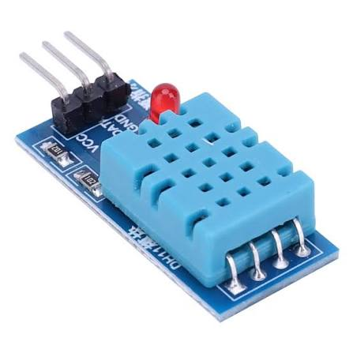

1. Small Description & Type
- Description: A basic, low-cost digital sensor that measures both ambient air temperature and relative humidity.
- Type: Composite sensor featuring a resistive-type humidity component and an NTC thermistor.

2. How it Works
- Humidity Sensing: A moisture-retaining substrate sits between two electrodes; as it absorbs water vapor, its electrical resistance changes.
- Temperature Sensing: A built-in Negative Temperature Coefficient (NTC) thermistor decreases its resistance as the surrounding temperature goes up.
- Processing: An onboard 8-bit microcontroller processes these raw resistance changes and transmits them as a single, calibrated digital data stream.
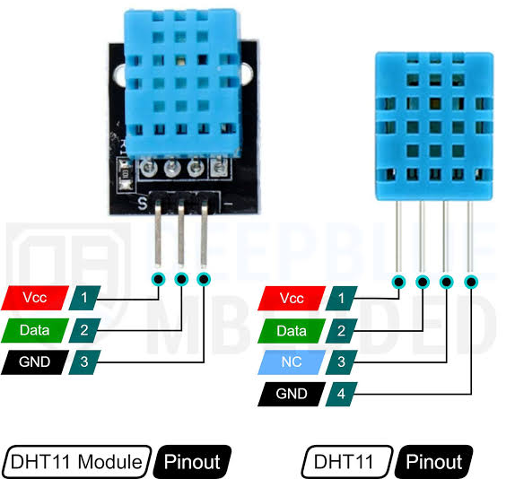

3. Pin Configuration (Standard 3-Pin / 4-Pin Modules)
- VCC: Power supply input (3.5V to 5.5V DC).
- DATA: Single-bus digital output pin (requires a 5k–10kΩ pull-up resistor to VCC if using the raw 4-pin sensor package).
- GND: Ground connection (0V).
- Note: On raw 4-pin packages, Pin 3 is NC (Not Connected).

4. Technical Specifications
- Operating Voltage: 3.5V to 5.5V DC
- Measurement Current: 0.3 mA (max during data conversion); 60 μA during standby.
- Humidity Range: 20% to 90% RH (Relative Humidity) with ±5% accuracy.
- Temperature Range: 0°C to 50°C (32°F to 122°F) with ±2°C accuracy.
- Sampling Rate: 1 Hz (One reading every 1 second).

5. Applications & Uses
- HVAC Systems: Basic indoor climate tracking, ventilation control, and home thermostat setups.
- Weather Stations: Low-cost consumer environmental monitoring rigs and data logging devices.
- Greenhouses: Automating exhaust fans or humidifiers based on indoor atmospheric shifts.

6. Safety Measures
- Sampling Delay: Do not query the sensor faster than its 1-second physical refresh rate, or the data readouts will time out, return errors, or stall your microcontroller loop.
- Condensation Risks: Prolonged exposure to 100% condensing humidity environments will degrade the internal substrate; use the higher-grade DHT22 sensor if the module must operate in dripping wet areas.
- Chemical Exposure: Keep the sensor away from heavy chemical vapors, volatile solvents, or heavy dust, which can permanently coat the internal components and destroy accuracy.

Relay Box
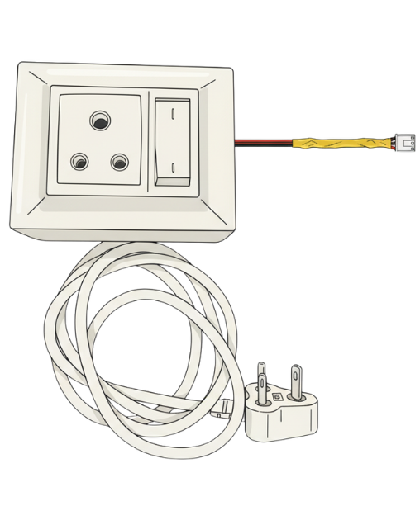

1. Small Description & Type
- Description: An enclosure housing one or more electromagnetic switches, designed to safely control high-voltage main appliances using low-voltage control signals.
- Common Type: Multi-channel Optocoupler-Isolated Relay Module Box (typically containing 1, 2, 4, or 8 relay channels).

2. How it Works
- Isolation: A low-voltage signal (like 5V from an Arduino) powers an internal optical isolator (optocoupler) to protect the controller from high-voltage spikes.
- Electromagnetism: The isolated current flows through a small internal coil, creating a magnetic field that physically pulls a flexible metal armature down.
- Switching: Moving the armature shifts the electrical connection from a default closed terminal over to an open terminal, completing the high-voltage circuit.
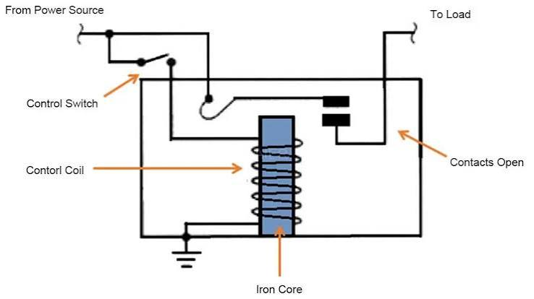

3. Pin Configuration
- Low-Voltage Input Side:
  - VCC: Power input for the coils/logic (typically 5V or 12V DC).
  - GND: Ground connection (0V).
  - IN (IN1, IN2, etc.): Digital input pins from the microcontroller to trigger each individual relay.
- High-Voltage Output Side (Per Channel):
  - COM (Common): The central line where the main external power source enters.
  - NO (Normally Open): Connects to COM only when the input pin is triggered (best for turning things ON).
  - NC (Normally Closed): Connects to COM by default; breaks the connection when triggered (best for safety shut-offs).

4. Technical Specifications
- Trigger Voltage: 5V or 12V DC (depending on the board model)
- Trigger Current: ~15 mA to 20 mA per channel
- AC Rating (Maximum): 10A at 250V AC / 15A at 125V AC
- DC Rating (Maximum): 10A at 30V DC
- Mechanical Life: Over 100,000 operations

5. Applications & Uses
- Home Automation: Controlling mains-powered lamps, ceiling fans, heaters, and home entertainment hubs.
- Industrial Control: Triggering high-draw AC water pumps, motorized gates, or manufacturing solenoids.
- Timer Circuits: Cycling power to heavy-duty battery chargers or appliance test racks safely.

6. Safety Measures
- Mains Hazard: AC electricity can cause severe shock or death; always disconnect the main power grid before touching the high-voltage screw terminals.
- Enclosure Security: Keep the module sealed inside a non-conductive plastic box to completely prevent accidental finger or tool contact with exposed high-voltage solder tracks.
- Inductive Loads: When controlling motorized loads (like a large fridge or pump), use a snubber circuit or a flyback diode across the lines to prevent arc welding the relay contacts shut over time.
- Current Overhead: Never exceed the absolute maximum rated current (10A); run continuous loads at roughly 70–80% capacity to prevent overheating.

